In today's data driven economy, organizations across all sectors are facing a common challenge, which is transforming and managing a massive volume of information. However, in reality, this volume of information frequently falls into a state of inconsistency, duplication or isolation within disconnected systems, making it difficult to collect, manage and exploit this new age gold mine. Master Data Management (MDM) is the optimal solution at the present time for this problem, by establishing a reliable "single source of truth" for the most critical data assets of an organization. As businesses increasingly depend on ERP platforms, CRM systems and cloud data architectures, the ability to govern and harmonize master data gradually becomes a key differentiating factor. This article will provide a brief overview of MDM, from its concept, the data domains it covers, its areas of application to how companies can effectively implement MDM within their systems.

1. What is Master Data Management?
Master Data Management (MDM) is a structured approach to define, manage and maintain the core data entities of an organization, also known as master data, across all systems as well as business processes.
Different from transactional data (which only records specific events in a discrete manner such as orders or invoices), master data represents reference information that is stable and reusable such as: who your customers are (customer MDM), what products you sell (products MDM), who your suppliers are (vendors MDM) and where your business operations take place (location MDM).
MDM establishes a centralized governance framework to ensure this foundational data source is always accurate, consistent and ready to serve any system that needs it, from ERP, CRM platforms to analytics tools and operational processes. Without MDM, organizations have a high probability of making decisions based on fragmented or even contradictory information, thereby leading to inefficiency, creating gaps in processes and degrading the customer experience. In reality, MDM is the combination of data governance policies, process design and supporting technology to establish a reliable data foundation, strictly managed and scalable according to the growth of the organization.

2. Examples of MDM
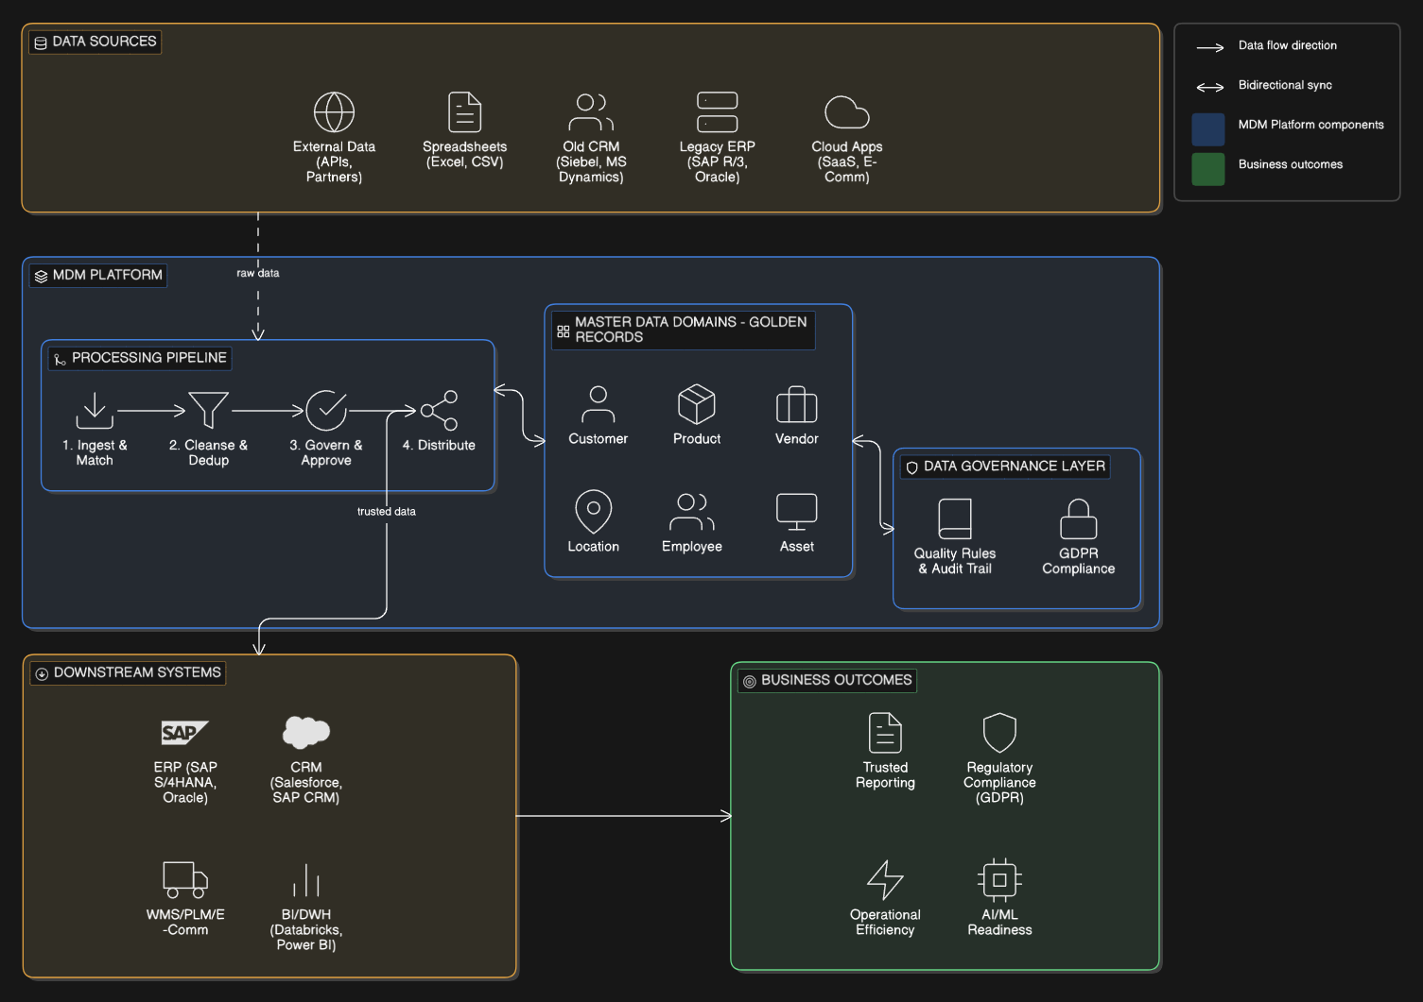MDM Domains and Core Business Entities
Customer Master Data
Customer Master Data includes all the core information that helps to uniquely identify and describe the customers of an organization. This volume of information includes names, addresses, contact information, account classifications and contractual relationships. In reality, this is the data domain most prone to encountering duplication and inconsistency. The reason is that customer records are frequently created and maintained through many different touchpoints, from CRM systems (like Salesforce or SAP CRM), payment platforms to customer support tools. MDM will solve this problem by consolidating those discrete records into a single and deduplicated customer profile (often called a "golden record") that all downstream systems can reliably use. This ensures that marketing, sales and customer care teams will always operate based on the same unified view of the customer, thereby minimizing the risk of contradictions in communication or missing opportunities to increase revenue. Industries such as financial services, telecommunications and retail are the sectors that benefit the most from customer master data management programs.
Product Master Data
Product Master Data defines the attributes of every item or service that an organization provides. These attributes include SKU codes, product descriptions, technical specifications, pricing and category hierarchies. It can be said that this data domain plays a central role for ERP systems (such as SAP S/4HANA), ecommerce platforms, Product Lifecycle Management (PLM) tools and supply chain applications. All these systems depend entirely on a synchronized and accurate source of product information. A lack of consistency in product data between systems will lead to direct failures in the operational stage, for example incorrect order processing, inaccurate inventory reporting and errors in financial forecasting. MDM provides a strictly governed product data repository, acting as a source of origin to distribute validated records to all consuming systems. For organizations operating across multiple markets or channels, maintaining an accurate and unique product catalog is the core foundation to build success in an omnichannel sales strategy.
Vendor/Supplier Master Data
Vendor/Supplier Master Data captures the essential attributes about external partners of an organization. Specifically, this includes legal entity names, banking details, tax identification numbers, payment terms and compliance certificates. This data domain is tightly integrated with the procurement modules of an ERP and the accounts payable system. In this area, supplier records that are flawed or duplicated can absolutely lead to duplicate payments, failed audit evaluations leading to the disruption of an entire supply chain. Applying MDM will help establish standardized onboarding processes for new suppliers, while ensuring that all changes (such as updating bank information or a new compliance status) are propagated consistently across all related systems. Especially in strictly regulated industries like pharmaceuticals or defense, the accuracy of supplier master data is also directly tied to legal and regulatory compliance obligations.
Location Master Data
Location Master Data refers to the structured representation of geographic or physical entities related to the business operations of an enterprise, including warehouses, retail branches, manufacturing facilities, delivery addresses and sales territories. This type of data is frequently used by Warehouse Management Systems (WMS), ERP logistics modules, field service applications and regional reporting tools. Any error in location data will quickly turn into incidents such as failed deliveries, skewed regional KPIs and illogical sales territory assignments. Through standardizing location hierarchies and geocoding, MDM ensures that all systems use a common, consistent and validated reference source for location based information. As organizations increasingly expand their operational scale across borders, location MDM becomes extremely critical for accurate operational planning and regulatory compliance reporting.
Asset Master Data
Asset Master Data covers the technical and financial attributes related to all physical assets as well as digital assets of an organization, for example machinery, production equipment, information technology infrastructure and other facilities. This is the fundamental basis for Enterprise Asset Management (EAM) systems, maintenance scheduling platforms and financial accounting modules, where assets must be closely tracked for depreciation and lifecycle management. The lack of accurate master data about assets will force enterprises to face skewed maintenance schedules, inaccurate book values and the loss of the ability to optimize capital expenditure decisions. MDM provides a unified registry that helps connect operational asset records with financial and compliance data, and this will be a powerful support for both daily maintenance operations and long term investment planning. This data domain is particularly highly strategic in capital intensive industries like energy, manufacturing and transportation.

3. Areas of Application
Data Cleansing and Standardization
Data cleansing is the first and most visible application of MDM. This is the process of identifying and correcting inaccurate, incomplete or duplicated records within master data domains. In reality, this work includes standardizing formats (such as address structures or naming conventions), resolving duplicated entities through matching and merging algorithms, while enriching records with validated reference data sources from the outside. MDM platforms provide rule based cleansing tools with the support of artificial intelligence to automate a large part of this process on a large scale. The result that this application brings is a clear improvement in data quality measurement metrics, specifically the duplication rate decreases, the completeness score is higher and the consistency between systems is significantly elevated.
Data Governance
MDM is inseparable from the data governance foundation. This is a framework including policies, roles and processes to define how master data is created, maintained as well as retired. In an MDM program, data governance plays the role of defining management responsibilities (meaning who will own which data domain), establishing quality standards and controlling approval workflows for every data change. Tools like SAP Master Data Governance provide governance capabilities embedded directly into the ERP ecosystem, allowing business users to manage master data within processes in a controlled and auditable manner. Effective governance will ensure that the data quality improvements achieved through the cleansing process will be sustainably maintained over time, instead of degrading when new records are continuously entered into the system.
System Integration and Data Harmonization
One of the core technical applications of MDM is the ability to enable consistent data exchange across heterogeneous enterprise systems, from ERP, CRM, ecommerce platforms to data warehouses and analytics tools. MDM acts as an integration backbone, maintaining a standard data model that all systems can reference, instead of letting each department maintain local and disconnected definitions themselves. This helps eliminate the role of point to point data mapping flows, which have become too complex, and contributes to significantly reducing the maintenance burden. For organizations undergoing ERP consolidation or cloud migration processes, MDM holds an extremely important role in harmonizing data models between legacy systems and modern systems. The final result is a more agile integration landscape, where new systems can be put into operation without disrupting existing data flows.
Regulatory Compliance and Risk Management
Organizations operating in highly regulated industries always have to rely on MDM to maintain data accuracy and auditability as required by legal frameworks such as GDPR, DORA or industry specific standards. For example, the GDPR regulation mandates that organizations must maintain accurate, continuously updated customer records and have the ability to fulfill requests from data subjects. These are tasks that can truly only be executed when the organization possesses a methodical customer master data management program. Similarly, financial institutions must also maintain master data about counterparties and financial instruments accurately to comply with reporting obligations such as BCBS 239. MDM provides audit trails, change histories and documentation on data lineage necessary to prove compliance to regulatory bodies. Not only stopping at the compliance issue, an accurate master data foundation also helps mitigate operational risks arising from decisions made based on faulty information.
Analytics, Reporting, and Business Intelligence
The quality of analytics and business intelligence results is always directly proportional to the quality of the foundational master data. MDM ensures that the multidimensional data used in reporting (such as customer segments, product categories or regional hierarchies) is always consistent across all data sources fed into a data warehouse or data lake. If there is no MDM, analysts will have to spend too large an amount of time on data reconciliation instead of focusing on generating valuable detailed insights. Once a well governed master data layer has been established, organizations can completely trust that sales reports, operational dashboards and executive scorecards of the leadership board all reflect a coherent and unified business picture. It can be said that MDM is the powerful driving factor for data driven decision making at all levels of the organization.
DataOps and Continuous Data Quality
Modern DataOps methods have expanded MDM beyond the framework of a one time implementation project to turn it into an automated and continuous operational principle. By integrating MDM processes into data pipelines following the CI/CD model, organizations can monitor master data quality in real time, automatically trigger remediation workflows when quality drops below the allowable threshold and track data lineage from end to end. This approach treats master data as a living asset continuously evolving with the enterprise, rather than just a static configuration maintained through periodic cleanup cycles. Cloud native MDM platforms carrying within them the ability to integrate with tools like Apache Kafka, Databricks or Azure Data Factory are exactly the keys that bring this operational agility. Through this, the organization can proactively manage data quality as an indispensable part of the standard daily operational rhythm.

4. Best Practices and Outlook for Companies
# | Best Practice | Explanation
1 | Define a governance framework first | Establish data ownership policies, quality rules, and approval processes before deploying technology.
2 | Choose the right MDM style | Registry, Consolidation, Coexistence or Centralised Hub, each architecture is suitable for different scales and levels of data dispersion.
3 | Start with highest-impact domains | Prioritize Customer or Product data, because this is where deviations cause direct business damage and it is the easiest to measure ROI.
4 | Integrate MDM into the data pipeline | MDM is not a one time project. Integrate it into the DataOps pipeline so that master data is continuously cleansed and updated.
5 | Measure data quality continuously | Establish clear KPIs: duplication rate, address accuracy, profile completion rate, and periodic reporting.
6 | Align business and IT stakeholders | MDM fails when it is only an IT project. The commitment of business owners is needed to maintain data quality in the long term.

Successful MDM programs all share a common set of foundational principles that help distinguish between sustainable implementations and short term data quality projects. The most important principle is clearly establishing data ownership right before selecting technology. If there are no designated managers taking responsibility for each master data domain, even the most sophisticated MDM platform will degrade over time.
Organizations should start with the data domain that brings the highest business impact, which will usually be customer or product data, and then gradually expand instead of trying to implement simultaneously across the entire enterprise scale at once. Implementing MDM also needs to be viewed as a continuous operational process and not a project with a deadline. Data quality must be measured regularly through clearly defined KPI metrics such as the duplication rate, the completeness of information fields and the consistency score across systems. The final point, a tight alignment between related parties in the business block and the information technology department is a prerequisite condition. MDM will certainly fail if it is viewed purely as a technology initiative instead of a shared business responsibility of the whole organization.
Regarding the vision in the future, the strategic importance of MDM will only increasingly rise as organizations are constantly accelerating on the digital transformation journey. The boom of artificial intelligence and machine learning applications has created a direct dependency on high quality master data sources. A model predicting the customer churn rate or an algorithm forecasting market demand will only be reliable if and only if the data source used to train them is truly accurate. This turns MDM into a prerequisite condition to create reliable AI models.
Cloud native MDM platforms are bringing better scalability and shortening the time to value. Meanwhile, integrating with DataOps and data mesh architectures is gradually shifting MDM from a centralized bottleneck into a distributed capability oriented towards specific data domains. Regulatory pressures across Europe, including the enforcement of GDPR and emerging data governance frameworks, further elevate MDM from a best practice into a mandatory compliance imperative. For companies committing to become data driven enterprises, MDM is absolutely not an optional optimization. It is the essential foundational layer that all data processing capabilities in the later stages must rely on.

Conclusion
Master Data Management brings a solid governance framework along with the technical infrastructure that organizations desperately need to ensure that their most important data assets always achieve high accuracy, maintain consistency and can be put into practical use throughout all systems and processes. From customer records, product information to data about suppliers, locations and assets, MDM comprehensively solves the management problem for all core business entities. At the same time, this solution also provides powerful support for downstream consuming systems such as ERP platforms, CRM and analytics tools which always depend directly on that data source.
In the context where data volumes are constantly increasing and digital architectures are becoming increasingly more complex, organizations that seriously invest in MDM programs in a thorough manner will have a much more solid position. Thanks to that, they can completely provide reliable analytical reports, fully meet all legal compliance obligations and confidently scale up their artificial intelligence initiatives. Ultimately, Master Data Management is exactly the most solid foundational layer to build a true data driven enterprise.

